CHE517 ADVANCED PROCESS CONTROL
FINAL EXAM
Professor Shi-Shang Jang Jan. 8, 2003

Problem #1 (20%)

Consider the following Internal Model Control Structure (or Model Predictive Control Structure:
G_{I}
G_{m}
G_{P}
y_{s}
e
d
y
y_{m}
u
+
+
+
-
-
+

Show that:

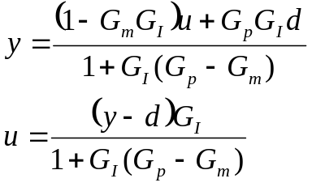

Based on the above derivation, also show that:
- Dual stability: y and u are both stable provided that G_{p}=G_{m}, G_{p} and G_{I} are stable.
- Perfect Control: y=y_{s} provided that G_{p}=G_{m}, G_{p}=G_{I}⁻¹ and G_{I} realizable.
- Zero offset: y(0)=y_{s}(0) provided that G_{m}(0)=G_{I}⁻¹(0).

Problem #2 Interpretation: (20%)

(1) Set point
- Manipulated variable (MV)
- Controlled variable (CV)
- Disturbance or load (DV)
- Process

Problem #3 (20%)

Consider the following process with three inputs and three outputs.
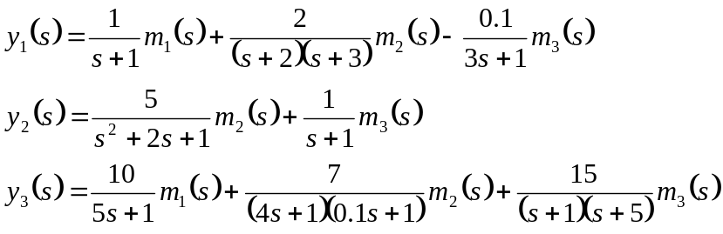
Using Bristol’s relative gain array, select the control loops with minimum steady state interaction.

Problem #4 (20%)

The following transfer function was provided by Waller et al.(1987) for a distillation column with the levels and pressure controlled with single loop controllers. The product qualities were not measured directly; they were inferred from tray temperatures (ºC) near the top, T₄, and near the bottom, T₁₄ trays. The manipulated variables are reflux, FR and reboiler steam, F_{S}, both in kg/h. Time is in minutes.
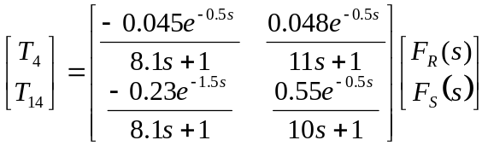
Answer the following questions for this system.
- Determine whether the input-output combination is controllable.
- Determine if either loop paring can be eliminated based on the relative gains (λij>0).
- Determine the initial tunings for PI controllers for all allowable loop pairings.
- Estimate whether the interaction affects the manipulated variable change between single-loop and multi-loop control.

Hint: The following Table should be useful:
 | P-only | PI | PID
Kc | τ/DKp | 0.9τ/DKp | 1.2τ/DKp
τ_{I} |  | D/0.3 | D/0.5
τ_{D} |  |  | 0.5D
Problem #5 (20%)
(a) Develop a feedforward-feedback control system for a process with the following transfer functions;
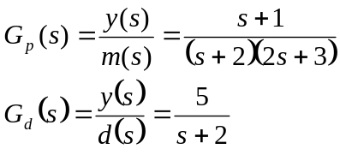
The following specifications are also given: (1) use a PI controller for the feedback loop, and (2) the feedforward system should have both disturbance rejection and set point tracking capabilities.

(b) Show how would tune the feedback PI controller.
(c ) Derive the conditions that must be satisfied in order to have stable closed-loop response. Do these conditions depend on both feedforward and feedback characteristics?

